Human Security System Using GPS Location

1RahulRajSingh,1AadityaAmitabh,1AnushkaSingh,1MuktaTehri,2Ashkaran Bisnoe

1,2DepartmentofAIT-CSE,Chandigarh University,Mohali,Punjab,India

***Abstract-*** The Human Security Assistance System with GPS Location Tracking and Messaging System can enhance human security by improving client management, preventing crime and terrorism, and enhancing surveillance programs. It uses a microcontroller, ESP8266 microcontroller, Arduino IDE software, and a wearable IoT-based system to track people's whereabouts and notify emergency contacts via SMS. The system ensures the safety of women, children, and the elderly, and can track large-scale population migrations during humanitarian crises. GPS technology can also be used to locate users in accidents or fires.

1. INTRODUCTION

The Human Security Assistance System with GPS Location Tracking and Messaging System is a proposed model for human security monitoring that can be used to ensure the safety of individuals. Human security is a paradigm for understanding global vulnerabilities that challenges the traditional notion of national security through a people-centered and multi-disciplinary understanding of security.

The proposed model can be used to enhance various aspects of human security and can be used to manage clients. The system can provide practitioners with a better understanding of GPS technology and its potential impacts on an agency's supervision program. The system can be used to ensure the safety of women and can provide alerts to nearby people in case of an emergency.

The system can be used to track the location of individuals and can send SMS alerts to emergency contacts, making it an effective tool for ensuring human security. The proposed model can be used to ensure the safety of individuals, especially children, elderly people, or women.

The system can be used to detect the location of the user and can send alerts to hospitals and fire service stations in case of fire alerts and accidents. The proposed model can be used to ensure the safety of individuals and can be an effective tool for ensuring human security.

The ability to use GPS to trace the movements of people raises important ethical issues. Continuous monitoring of one's activity by a researcher, even where consent is initially given, poses the threat of invasion of privacy and may lead to psychological implications from the feeling of being "watched".

The use of GPS technology to monitor individuals raises questions about individual privacy rights. There are concerns about the amount of information that can be deduced from a person's movements and how that information may be used. Geo-location privacy legislation prohibits the use of this technology for routine surveillance activities.

1. LITERATURESURVEY

The literature survey for the human security system using GPS location project includes six relevant articles. The articles cover a range of topics related to the use of GPS technology in enhancing human security. The following is a summary of the articles:

"A Proposed Model for Human Securing using GPS": This article presents a system architecture for human security monitoring using GPS technology. The proposed model can be used in personal locators for children, elderly people, or women.

"Improving National Security Using GPS Tracking System Technology": This article explores the use of GPS tracking technology in improving national security. The article highlights the potential applications of GPS technology in enhancing security and safety.

"Mobile Safety Alarms Based on GPS Technology in the Care of Older Adults": This article discusses the use of GPS alarms in supporting independent activities of older adults. The article highlights the potential applications of GPS technology in ensuring the safety of individuals.

"Global Positioning System (GPS) Technology for Community Supervision: Lessons Learned": This article discusses the use of GPS technology in community supervision. The article highlights the potential benefits and challenges of using GPS technology in community supervision.

"Strengths and Weaknesses of Global Positioning System (GPS) Data-Loggers and Semi-structured Interviews for Capturing Fine-scale Human Mobility: Findings from Iquitos, Peru": This article discusses the strengths and weaknesses of GPS data-loggers and semi-structured interviews in capturing fine-scale human mobility. The article highlights the potential applications of GPS technology in studying human mobility patterns.

"The use of Technology of Global Positioning System (GPS) in Criminal Investigation & Right to Privacy under the Constitution and Criminal Legislations in Jordan": This article discusses the use of GPS technology in criminal investigation and the right to privacy. The article highlights the potential benefits and challenges of using GPS technology in criminal investigation.

Overall, the literature survey highlights the potential applications of GPS technology in enhancing human security. The articles provide valuable insights into the use of GPS technology in personal locators, national security, community supervision, and criminal investigation. The survey also highlights the potential applications of GPS technology in studying human mobility patterns and ensuring the safety of individuals.

1. PROPOSEDSYSTEM

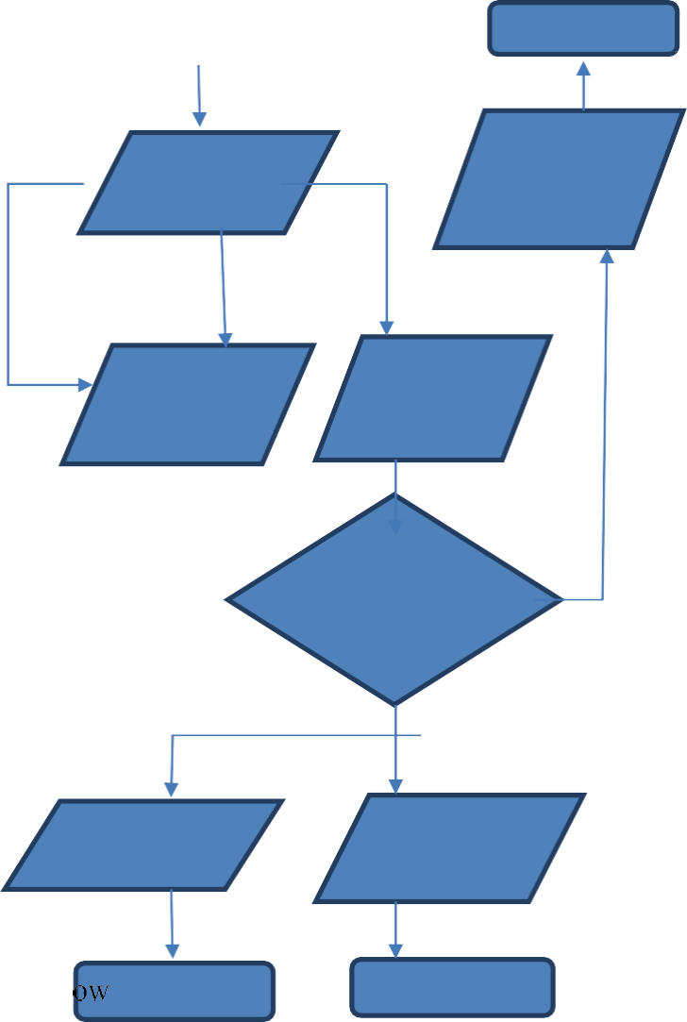

STAR

STO

CAPTUREAIR

TWEETGOOD

Everytwo

UPLOAD DATATO

DISPLAYLCD

IF AIRQUALITY<

N

BUZZER

TWEETBADAIR

ChaTr

STO

The proposed system for the human security system using GPS location project can be developed using Java programming language. Java is a widely used programming language that is known for its security features. The proposed system will be designed to ensure the safety of individuals while addressing privacy, ethical, and technological concerns. The following components will be included: GPS tracking device, Inertial Measurement Unit (IMU), Inertial Navigation System (INS), Information Security (INFOSEC), Geographic Information System (GIS), Global Navigation Satellite System (GNSS)

1. SYSTEMDESIGN

The MQ135 air quality sensor and Node MCUare utilized inthehardwareportionofthesystem.Thissensorcandetectsmoke, CO2, CO, ammonia, and other gases. Because Arduino lacks Wi-Fi functionality, we must utilize the Node MCU, also known as the ESP8266 Wi-Fi chip, and connect it to our mobile hotspot in order to communicate this data to the cloud. One of the most often used power sources in use today is the 5V power source. An LCD display that is frequently used for interacting with embedded systems is the H44780 Character LCD. In this project, we're using the 16X2 Configuration's 4-bit write mode.

Figure:FlowChartofAirQualityMonitoringSystem



MQ-135



POWERSUPPLY

NODEMCU

LCDDISPLAY

Buzzer

Fig. 2

Figure: Block Diagram Air QualityMonitoringSystem

Fig.1

1. RESULTANDDISCUSSION

Access to Wi-Fi or the internet is made possible by the ESP8266 Wi-Fi module for the project. It is a cost-effective solution that gives your projects a lot of power. It is the most advanced gadget on the Internet of Things platform and can interface with any microcontroller. More information on this.Then,anArduinoandMQ135sensorwillbecoupled.TheVCCandgroundconnectionsof the sensor should be connected to the Arduino’s 5V andground, and the analogue pin should be connected to theArduino’s A0. To make a buzzer start beeping when thecondition is satisfied, connect it to Arduino pin 8.The MQ135 sensor is the ideal choice because it can identify NH3, NOx, alcohol, benzene, smoke, CO2, and a few more compounds.

350 PPM is the highest permissible level of air quality, and it shouldn't go over 1000 PPM. Headaches, weariness, and stuffy, stagnant air start to occur when it exceeds the limit of 1000 PPM. If it rises above 2000 PPM, it may potentially worsen your health and increase heart rate. The LCD and website will display "Good Quality of Air" when the reading is less than 1000 PPM. A buzzer will start to sound whenever the figure goes over 1000 PPM, and the LCD and website will display "Bad quality of air."

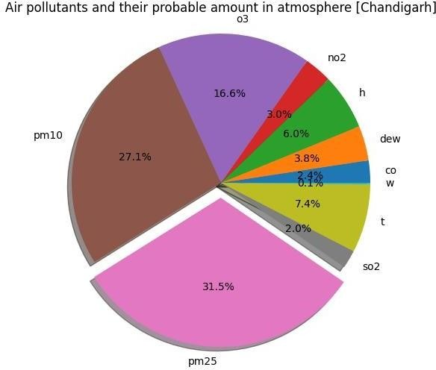

Fig.3:PieChartShowingPollutantsPercentageinAir

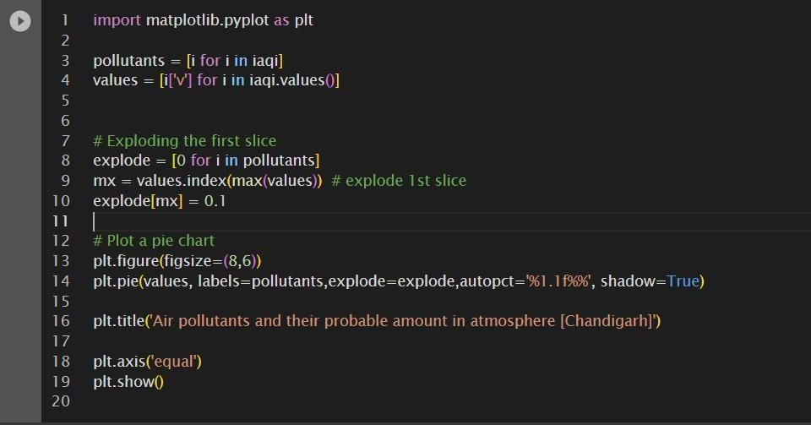

Fig.4)PythonCode to plotPie Chart

UsingthePythonMatplotlibpackage,theprovided codegenerates a pie chartshowing the most likely concentrationof air contaminants in Chandigarh's atmosphere. Let us step-by-stepdissectthe code:

1. Usingintherequiredlibraries:



Using the Python Matplotlib package, the provided codegeneratesapiechartshowingthemostlikelyconcentrationofaircontaminantsinChandigarh'satmosphere.Let'sstep-by-stepdissectthecode

1. Usingintherequiredlibraries:

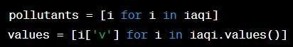

Inthiscase,theiaqivariable—whichisassumedtobe adictionary—is transformed into a list comprehension namedpollutants,andthosenamesareextractedfrom it.Withtheuseoftheiaqidictionary,valuesisadistinctlistcomprehension that extracts the values associated with eachpollutant.

1. Explodingthefirstslice:

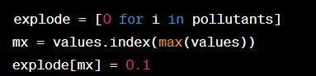

This step generates an explode list that is the same length asthe pollutants list. The initial value of each element in theexplodelistis0.Theelementintheexplodelistthatcorrespondstothatpositionisthensetto0.1usingtheindex() method to locate the greatest value in the values list.This is done to visually distinguish the slice of the pie chartthatrepresentsthepollutantwiththegreatestvalue.

1. Plottingthepiechart:

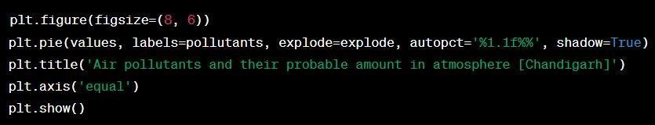

The pie chart's actual creation and presentation fall underthepurviewofthissection.

Using the command plt.figure(figsize=(8, 6)), a new figure with the specified 8 by 6 dimensions is created.

Thefunction plt.pie(values, labels=pollutants, explode=explode) creates the pie chart.

autopct='%1.1f%%',shadow=True).Eachpollutant'sname islisted in thelabels list, which also contains thevalues for each slice. The explode list decides whether anysliceshouldbevisuallyseparated,andautopct='%1.1f%%' formats the percentage labels to haveone decimal place. Finally, shadow=True adds a shadoweffecttothechart.

Thetitleofthechartisspecifiedusingplt.title("Airpollutantsandtheirprobableamountinatmosphere[Chandigarh]").

The pie chart is displayed as a circle rather than an ellipsethankstoplt.axis('equal').

Thechartisshownonthescreenbyplt.show().

Overall, the code creates a pie chart showing slices withlabels that correspond to the likely concentrations of aircontaminantsinChandigarh'senvironment.Forbettervisualisation,the slice of the pie chart that represents thepollutant with the greatestvalueis slightlyoffset fromtheotherslices.

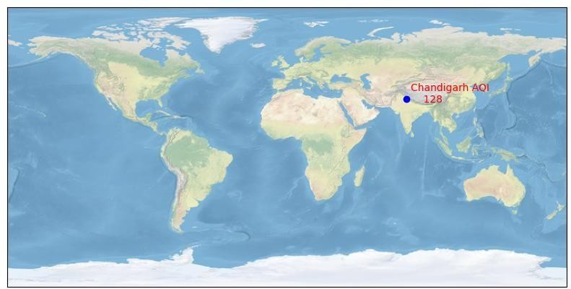

Fig.4)ShowingMapof acitywithit’sAQILevel

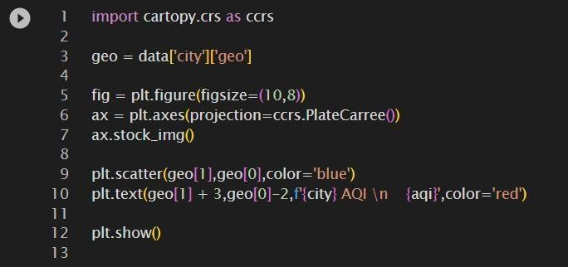

Fig.5)PythonCodetoshowmapofthecitywithAQILevel.

The provided code plots a scatter point reflecting a city'sgeographic position on a map and displays the AQI (AirQuality Index) value related to that city using the Cartopylibrary in Python.Let'sgooverthecodelineby line:

1. Therequiredlibrariesareimported:



This line imports the cartopy.crs module from the Cartopylibrary, which supports a numberof different coordinatereferencesystems andmapprojections.

1. Gettingthegeographiccoordinates:



This phrase assumes that there is a dictionary called datathathasinformationaboutthecityinit.Thecity'sgeographiccoordinates,latitudeandlongitude,areextractedandkept inthegeovariable.

1. Thefigure's axesaremade:

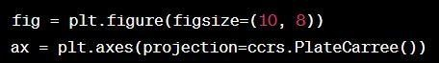

Using plt.figure(figsize=(10, 8)), a figure with the desireddimensions of10 by 8 inches is created inthis section.ThemapprojectionisthenchangedtoPlateCarrée(equidistant cylindrical projection)usingplt.axes(projection=ccrs.PlateCarree()),whichalsoproducesanaxesobjectcalledaxe.

1. Includingastockphototothestory:



With the addition of this line, the plot gains a stock imagethat gives a background map with coastlines,land, andocean regions.

1. Thescatterpointandtextlabelareplotted:



Using the longitude (geo[1]) and latitude (geo[0]) values,the function plt.scatter(geo[1], geo[0],color='blue') plots ascatterpointonthemap.Thepointiscoloured blue.

With the help of the function plt.text(geo[1] + 3, geo[0] -2, f'city AQI n aqi', color='red'), the text "city AQI" isplaced adjacent to the scatterpoint. The text uses thewords "city" and "aqi" interchangeably. The parametersgeo[1] + 3 and geo[0] - 2 specify where the text label willbe in reference to the scatter point. The hue of the textlabeliscrimson.

1. Displayingtheplot:



Onthescreen,thisline presentstheplot.

In general, the code produces a map plot using Cartopy,where a scatter point denotes a city's precise location.Near the scatter point, a text label with the AQI value isvisible.Thebackgroundofthemapisastockphoto.

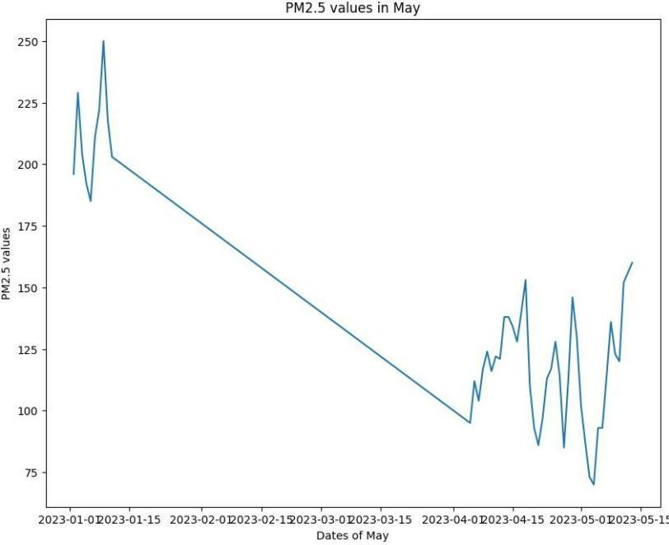

Fig.5)GraphShowingPM2.5 values

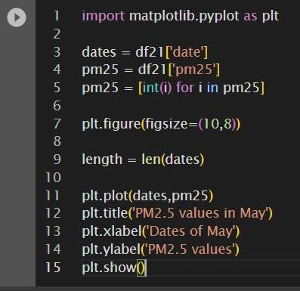

Python Codetoshowgraph

The provided code generates a line plot of the PM2.5 valuesovertime,specificallyforthemonthofMay,usingthePythonMatplotlibpackage.Let'sstep-by-step dissectthecode:

1. Therequiredlibrariesareimported:



Thislineimportsthepyplotmodulefromthematplotliblibrary,whichgivesusersastraightforwardinterfaceformakingdifferentkindsofplotsandcharts.

1. Settingtheparameters:

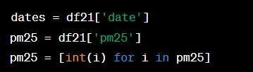

DatesandPM25aregivenvaluesfromthe"date"and"pm25" columns of a DataFrame in this example. The 'pm25'valuesarealsotransformedintointegersusingalistcomprehension.

1. Creatingthefigureandsettingitssize:



With the supplied dimensions of 10 inches by 8 inches, thislinegeneratesa newfigure.

1. Layingdownthelinegraph:

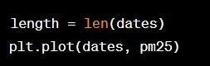

Creatingalineplotrequirestheusageoftheplt.plot()function. The 'dates' and 'pm25' values areplotted on the x-and y-axes, respectively. To demonstrate a trend or patternacrosstime, a lineisdrawnconnectingthedatapoints.

1. Incorporatingatitle,x-axislabel,andy-axislabel

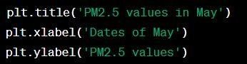

These lines provide the y-axis label as "PM2.5 values,"the x-axis label as "Dates of May," and the plot title as "PM2.5values."

1. Presentingthestory:



Onthescreen,thislinepresentstheplot.

Overall, the code creates a line plot that shows the PM2.5values over time in the month of May. The y- axis displaysthe relevant PM2.5 readings, and the x- axis displays thedates.There isa screen showingtheplot.

CONCLUSION

The MQ135 Gas Sensor is used by this system to send gas, such as benzene, alcohol, smoke, etc. By using an Arduino microcontroller to monitor the air quality of the area, IOT technology is said to improve air quality. The use of Io technology enhances the process of monitoring various environmental parameters, such as the air quality monitoring issue raised in this study. This board's Wi-Fi module functions as both an internet connection and an informational portal for the air quality. To measure the air quality in real-time, this uses a MQ135 Gas Sensor and Node MCU. Node MCU will send information to the Things Peak platform, which is linked to Twitter, when the air quality drops below a set threshold so that it may send the Twitter notification and warn the neighborhood. Here, the MQ135 gas sensor is used to detect a range of hazardous substances, while Arduino, the project's brain, regulates every step of the procedure.The visual output is provided by an LCD, and the system as a whole is linked to the internet by a Wi-Fi module. It successfully supports modern technologies while still advocating for a healthy lifestyle. The capabilities of this system and an app for smartphones can be used by people to monitor the pollution level.

1. REFERENCES
   1. S.KumarandA.Jasuja.Airqualitymonitoringsystembasedoninternetofthingsusingraspberry

pi.Pages1341-1346,May2017.

* 1. S.R. Enigella and H. Shahnasser. Real-time air qualitymonitoring.Pages182-185,Jan2018.
  2. D. Wang, C. Jiang, and Y. Dan. Design of air qualitymonitoringsystembasedontheinternetof things.Pages418-423,Dec2016.
  3. L. Peng, F. Danni, J. Shengqian, and W. Mingjie. Amovableindoor air quality monitoring system.Pages126-129,July2017.
  4. Sumanth Reddy Enigella, Hamid Shahnasser. "Real-TimeAirQualityMonitoring",201810thInternationalConferenceonKnowledgeandSmartTechnology (KST),2018.
  5. [www.irjet.net.](http://www.irjet.net/)
  6. Poonam Paul, Ritik Gupta, Sanjana Tiwari, AshutoshSharma, “IoT based Air Pollution Monitoring SystemwithArduino”,UART, May2005.
  7. Zishan Khan, Abbas Ali, Moin Moghal,” IoT basedAirPollutionusingNodeMCUandThingspeak”,IRANS, pp.11-16,March2014.
  8. Mohan Joshi, “Research Paper on IoT based Air andSound Pollution monitoring system”, IETSJournal,pp.11-17,September2015.
  9. "MalayaRanjan,RajKumar,"UnderstandingPartsper million in real-time air quality index", Journal ofMathematicsandadvancedsciences,pp.23-29,

September2009

* 1. H. Kopetz, Real-Time Systems: Design Principles forDistributedEmbeddedApplications.Boston,MA:Springer US, 2011, ch. Internet of Things, pp. 307-323.
  2. FouziHarrow,MohamedNounou,HazemNounou“Detecting Abnormal Ozone Levels Using Pea BasedGirHypothesisTesting”2013IeeeSymposiumOnComputationalIntelligenceAndDataMining.
  3. Srinivas Devarakonda, Parveen Sevusu, Hong HangLiu, Ruilin Liu, Liviu Iftode, Badri Nath Urbcomp“Real-Time Air Quality Monitoring Through MobileSensingInMetropolitanAreas”13,August2013Acm.